**Assignment**

**Math Optimization I**

**ISM-6436 Operations & Supply Chain Processes**

1. Maggie’s Pottery Barn is a mid-sized pottery shop selling handmade pottery to tourists in Cherokee, North Carolina. Seven products of interest are 1) standard clay mugs, 2) wolf mugs, 3) cat mugs, 4) right-handed hand warmer mugs, 5) left-handed hand warmer mugs, 6) clay serving trays, and 7) 10-inch clay bowls. (Some of these products are shown in the embedded document below.) The products are made and fired in Maggie’s shop where tourists can watch, and then sold to tourists in a showroom. Maggie’s currently has 18 full-time employees working 8 hours each day for 22 days per month. Employees are paid $10 per hour. For the current month Maggie’s has 8000 pounds of clay, costing $0.70 per pound. Revenue and other details for each product are given in the table below. 

|  |  |  |  |  |  |  |  |
| --- | --- | --- | --- | --- | --- | --- | --- |
|  | 10-in. Bowl | Standard Mug | Wolf Mug | Cat  Mug | RH Warmer | LH Warmer | Serving Tray |
| Retail  Price/Unit | $60 | $15 | $25 | $40 | $35 | $35 | $60 |
| Clay lbs. Needed | 4 | 1 | 1 | 1 | 1 | 1 | 3 |
| Labor Hrs.  Needed | 1 | 1 | 1.7 | 2.3 | 2 | 2 | 1 |
| Overhead Cost/Unit | $3 | $3 | $3 | $3 | $3 | $3 | $3 |

Formulate and solve the math optimization model which will maximize overall profit by determining the mix of the seven products to be produced this month. Maggie’s has certain other restrictions which must be reflected in your solution. These are:

1. At 500 mugs in total (combined for all types of mugs) must be produced.
2. At least 50 cat mugs must be produced.
3. At least 5% of all hand warming mugs produced must be left-handed mugs.
4. At most 15% of all hand warming mugs produced can be left-handed mugs.
5. No more than 300 hand warming mugs of both types may be produced.
6. There number of wolf mugs produced must be greater than or equal to the number of cat mugs produced.
7. The number of standard mugs produced must be equal to or greater than the total number of wolf mugs and cat mugs.
8. The number of bowls produced must be equal to or greater than the number of serving trays.
9. 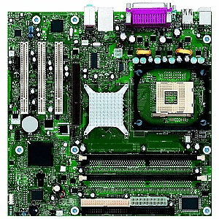BP Computer Services assembles its own brand of personal computers from component parts it purchases overseas and domestically. BP has enough regular production capacity to produce up to 2000 computers per week. It can produce an additional 800 computers with overtime. The cost of assembling, inspecting, and packaging a computer during regular time is $190. Overtime production of a computer costs $260. Further, it costs $20 per computer per week to hold a computer in inventory for future delivery, but BP’s storage facility can store a maximum of only 500 computers. BP wants to meet all customer orders with no shortages to provide quality service. BP’s confirmed orders for the next six weeks are given below.

|  |  |  |  |  |  |  |
| --- | --- | --- | --- | --- | --- | --- |
| Week | 1 | 2 | 3 | 4 | 5 | 6 |
| Unit Orders | 1800 | 2600 | 2800 | 2900 | 900 | 3300 |

1. Determine the least cost master production schedule and inventory plan for BP given the availability of regular and overtime production and inventory storage.
2. BP is considering engaging a subcontractor for computer assembly to help meet customer orders during peak times. The subcontractor will charge $225 per unit for assembly, but as the arrangement is on a trial basis the subcontractor will only devote a limited portion of their capacity to BP. They can assemble up to 700 computers per week. Determine how much BP might save in production and inventory costs over the six-week horizon if they could use the contractor each week.
3. 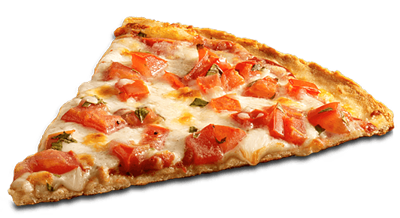Al Forno is a local pizza restaurant that is participating in an upcoming Italian Heritage festival this Saturday. At the festival Al Forno will have a small tent and be selling slices of pizza to festival attendees. On this occasion Al Forno’s owners know that any kind of pizza offered will sell. Al Forno will offer plain, meat, vegetable, and supreme pizzas for sale by the slice at the festival. Each variety has its own requirement for sauce, cheese, dough, and topings as shown in the table below. Each variety has its own selling price per slice. Al Forno wishes to maximize revenues from sales of slices of pizza.

|  |  |  |  |  |  |
| --- | --- | --- | --- | --- | --- |
|  | Cheese | Meat | Vegetable | Supreme | Available |
| Dough (oz.) | 5 | 5 | 5 | 5 | 125 lbs. |
| Sauce (oz.) | 3 | 3 | 3 | 3 | 7 gallons |
| Cheese (oz.) | 4 | 3 | 3 | 4 | 100 lbs. |
| Meat (oz.) | 0 | 3 | 0 | 2 | 50 lbs. |
| Vegetables (oz.) | 0 | - | 3 | 2 | 30 lbs. |
| Price/Slice | $5 | $8 | $6 | $9 |  |

1. Formulate and solve the linear programming model which will determine the mix of pizza types to maximize revenue. Make sure your model allows for the number of slices produced of each type to be at least 15% of the total number of slices produced.
2. Al Forno employee Buster Bocelli can be ready at main restaurant to bring more of any ingredients required to make more pizza slices and increase revenue. He’ll deliver them to the festival quickly in the restaurant’s delivery vehicle, the Fornomobile. According to your model which ingredient(s) would be immediately required to increase units and revenue?
3. Acme Communications operates a regional call center where the workday is broken down into six 4-hour shifts, and each associate works two consecutive shifts for an 8-hour day. The table below describes labor headcount needed on each shift. The call center’s manager wishes to assign associates to the six available starting times so that the staffing requirements are covered in each period.

|  |  |  |  |  |  |  |
| --- | --- | --- | --- | --- | --- | --- |
| Shift | 02:00-06:00 | 06:00-10:00 | 10:00-14:00 | 14:00-18:00 | 18:00-22:00 | 22:00-02:00 |
| Need | 10 | 20 | 45 | 40 | 50 | 12 |

1. Full-time associates are currently employed at $15 per hour with a $3 per hour shift premium for those working between 10 PM and 6 AM. Determine the optimal method for scheduling associates to minimize the daily wage cost.
2. The employment of part-time associates is being considered. Part-timers would be employed for only one 4-hour shift in a work day. They would be paid $9 per hour with the same arrangement for the $3 shift premium as full-time associates. To make sure enough experienced associates are always on hand the number of part-timers may not exceed the number of full-timers at any given time of the day. Determine how much could be saved in daily wage cost if part-time associates were employed.

**Instructions:** Your deliverable will be a functioning Excel spreadsheet with each problem on a separate worksheet page. For each problem a fully populated Solver dialog box will be available and your model should solve in a test by the instructor. The deliverable will be uploaded to Canvas by the assignment deadline stated on the Lesson Plan. Include a cover page for your file which lists your name and the names of any other group members deserving credit for this work. Group sizes may be no larger than 4, and only one group member need submit the final deliverable.